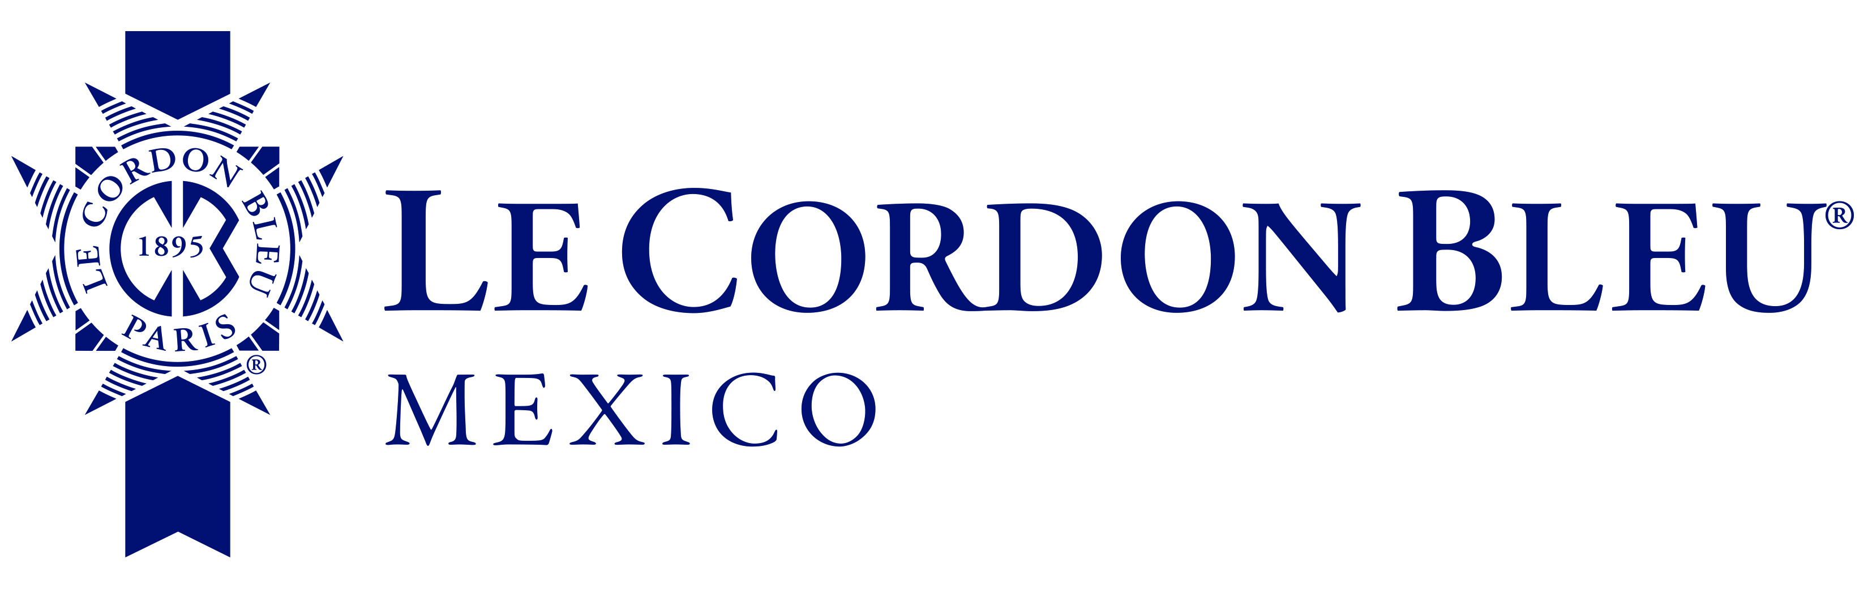

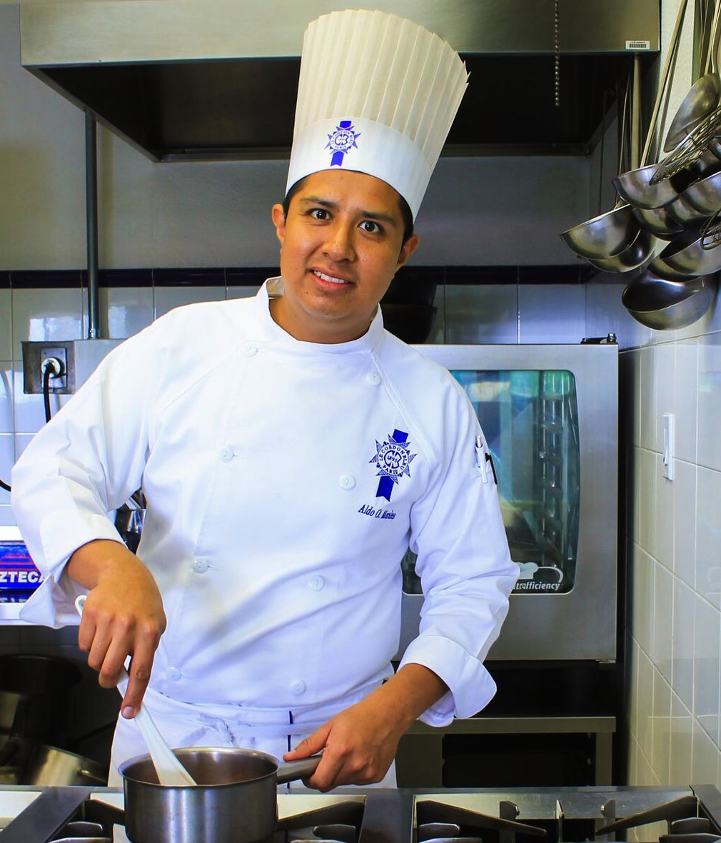

Aldo Omar Morales is an up-and-coming chef born in Mexico City, and is passionate about marrying French techniques with the broad palette of flavors in traditional Mexican cuisine.

He began his training in a very traditional restaurant in Mexico City called "Hacienda de los Morales", receiving the Certificate of Professional Qualifications from the Culinary Academy of France.

He continued his restaurant training at "Pablo Gallego" in La Coruña, Spain, after this experience he returned to Mexico to continued his cooking training in the restaurant Cordon-Bleu Casa de Francia.

He receives the award "Turquois Foundation" scholarship to study at the Lycée Technique et Hôtelier de Monte-Carlo, and he apprenticed at the Hermitage Hotel in Monaco.

Now, his doing a Master in Management of Gastronomic Business in the University Anahuac Norte in Mexico.

He is currently a chef instructor at the prestigious Culinary Arts School "Le Cordon Bleu Mexico," encouraging the skills of a new generation of international students.

